**ECEN 214 - 302**

**Lab member: Alex Allahar**

**TA: Navid Naseh**

**Date lab performed: 07/26/22**

**Date report is due: 07/29/22**

1. **Procedure**

During this lab, I designed a Sallen Key circuit to create any desired 2nd order circuit response. The circuit was analyzed to get general expressions related to the behavior of the Q-factor in terms of circuit component values. Before the lab began, these general expressions were used to choose these circuit components that created circuit responses with frequencies of 1 kHz and varying Q values. The circuits were then analyzed in LTSpice.

Then, during the lab, I built the Sallen-Key circuit with the component values found during prelab. Beginning with Q = 0.5, then Q = 0.25, then Q = 0.1, then Q = 1, and finally Q = 2.5. Then, a 100Hz square wave with a peak-to-peak voltage of 2 Volts was used as input, and the input and output waveforms were viewed on the AD2.

1. **Data and Results**
   1. Theoretical

Attached in pdf with Lab Submission

* 1. Simulations

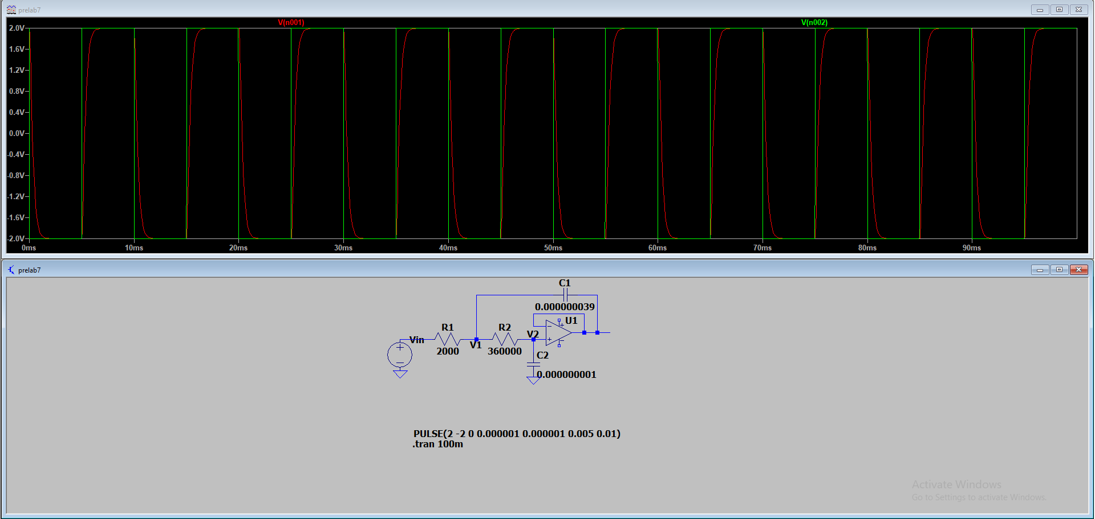

Figure 1: LTSpice simulation for Q = 0.5

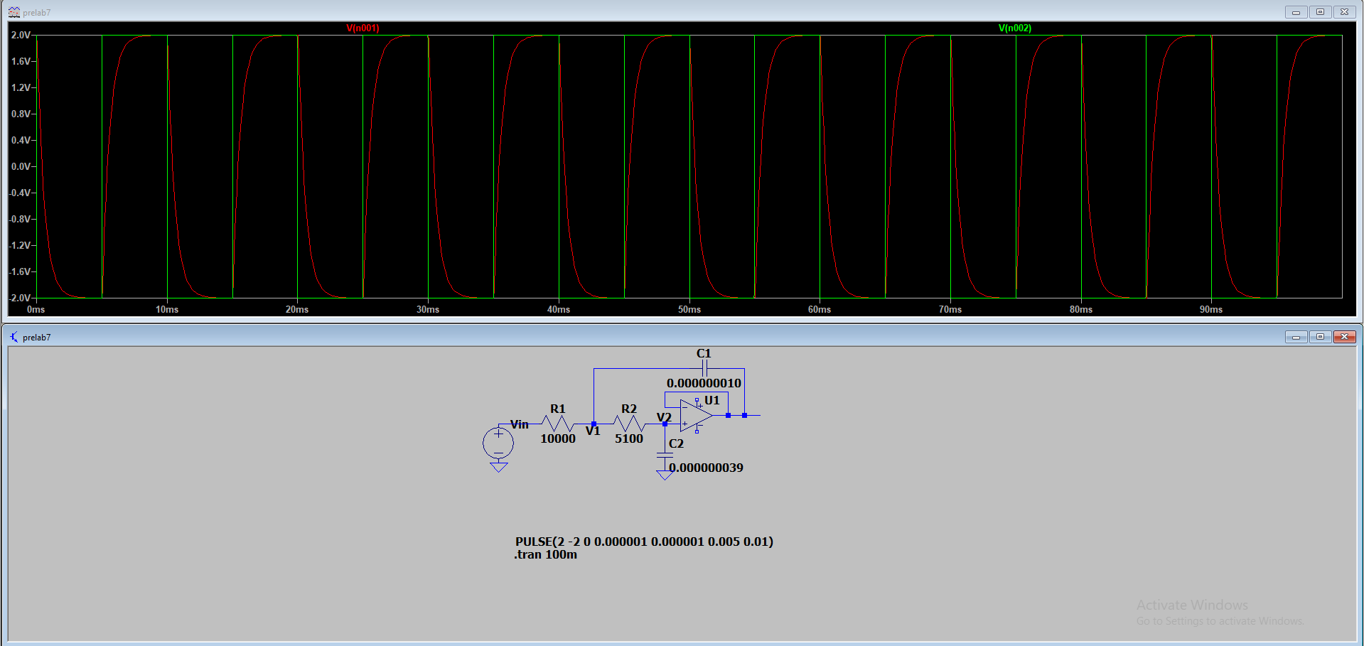

Figure 2: LTSpice simulation for Q = 0.25

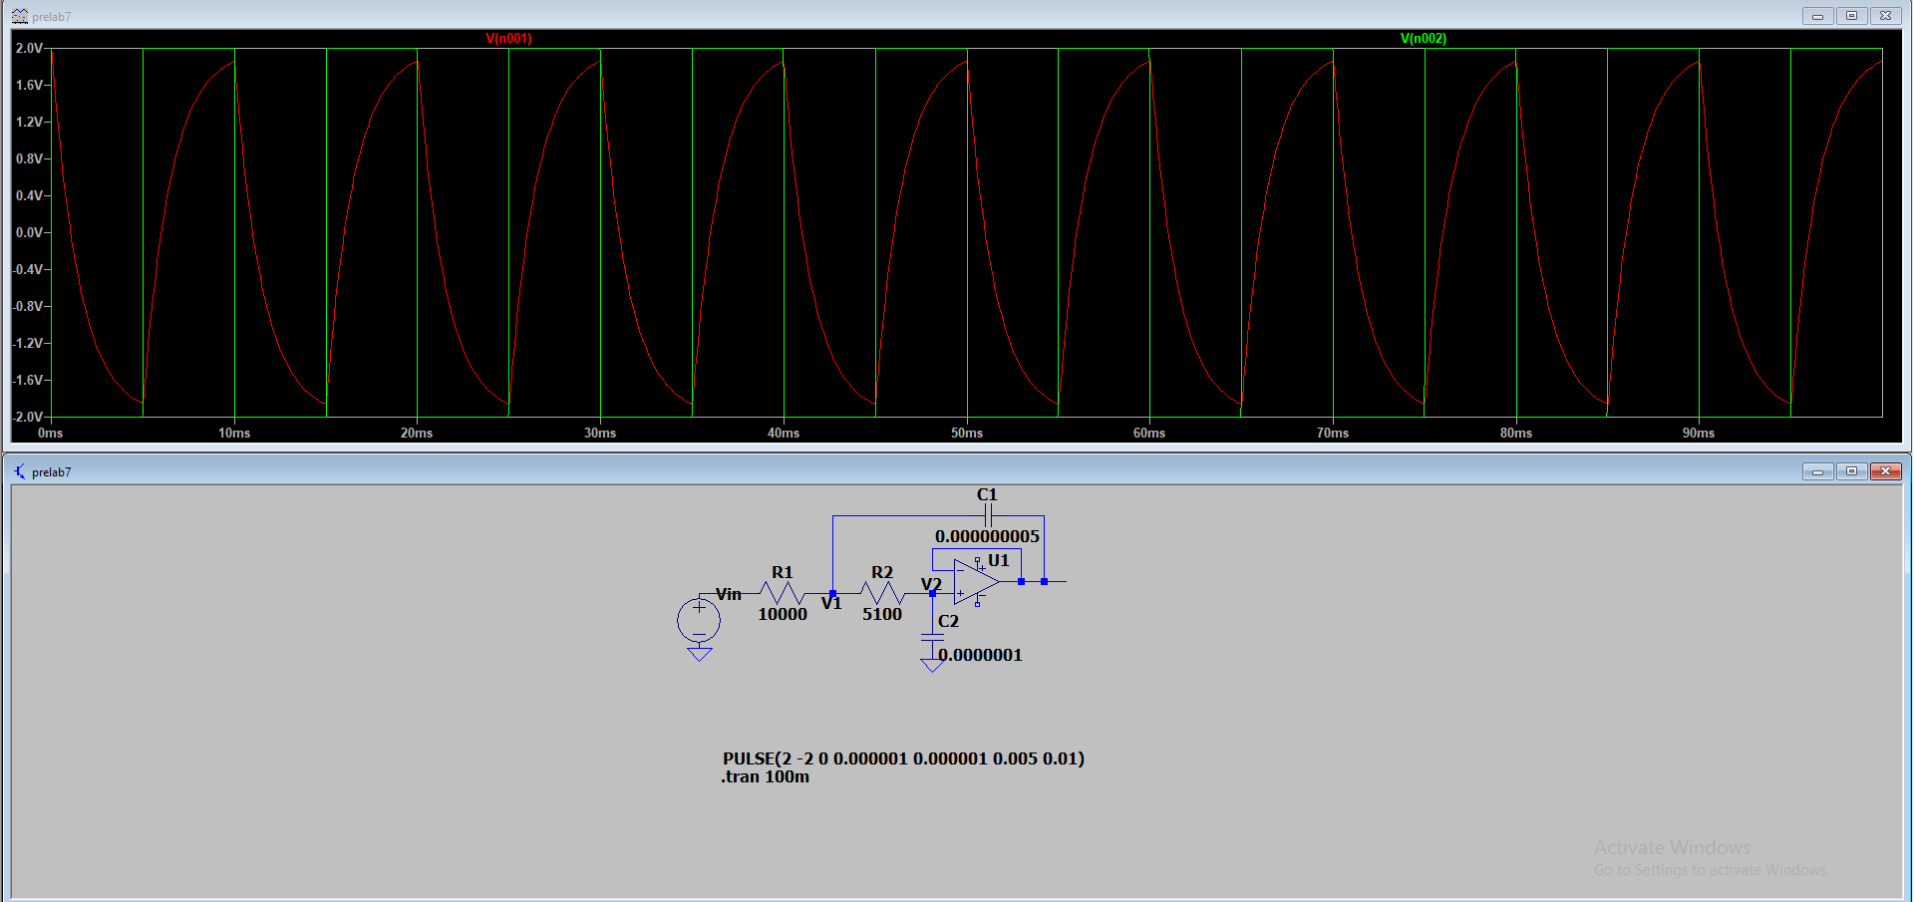

Figure 3: LTSpice simulation for Q = 0.1

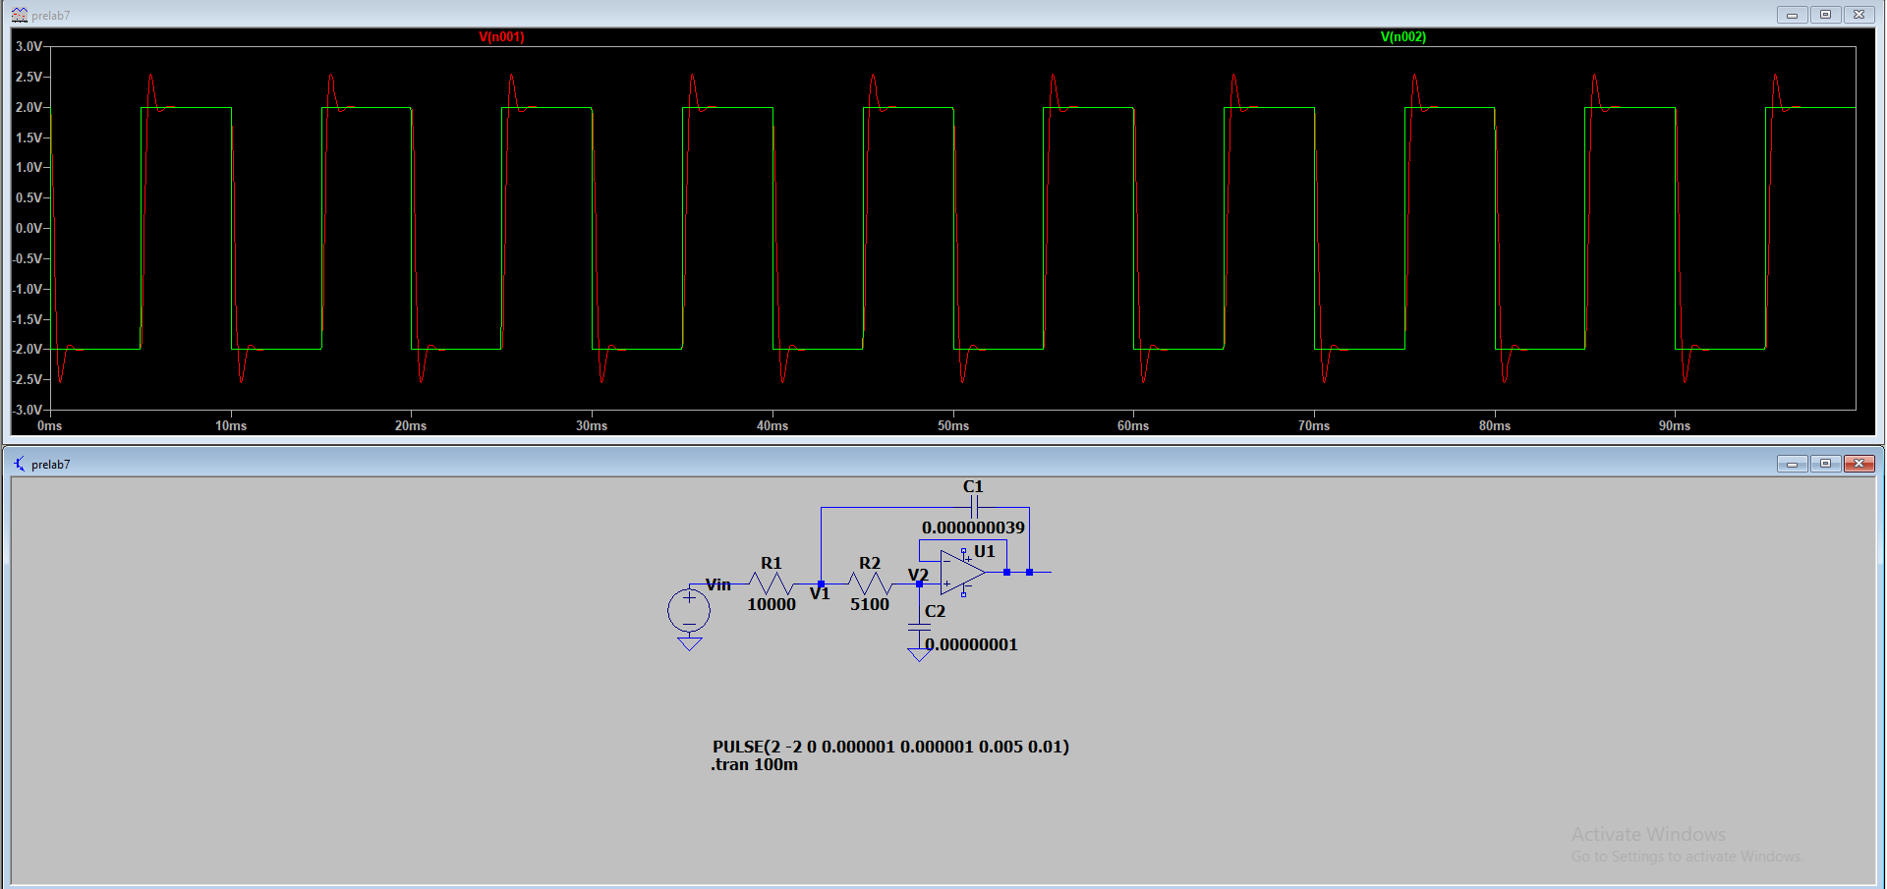

Figure 4: LTSpice simulation for Q = 1

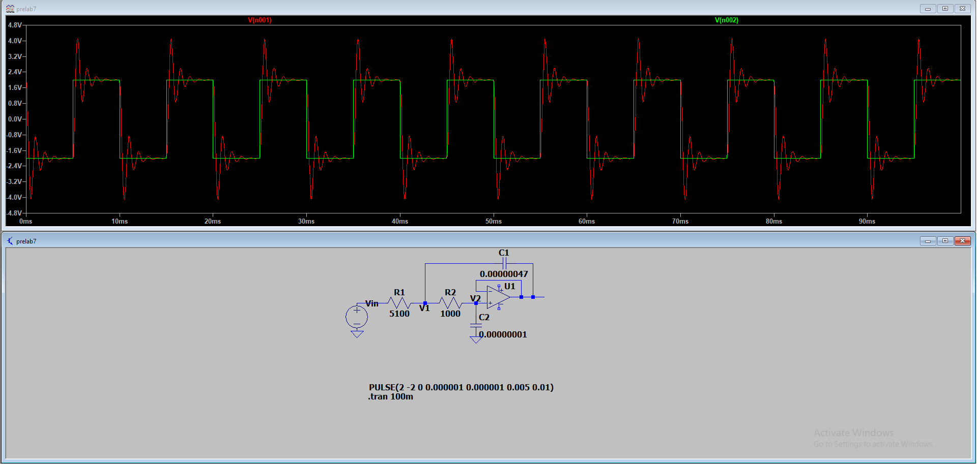

Figure 5: LTSpice simulation for Q = 2.5

* 1. Measured

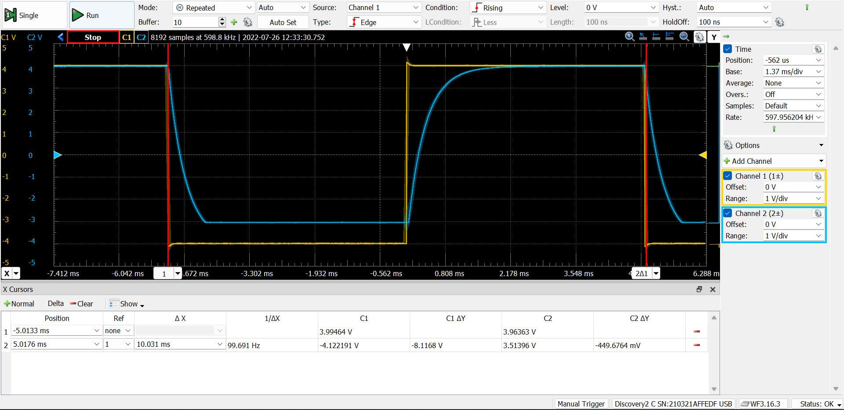

Figure 6: Measured waveforms from lab for Q = 0.5

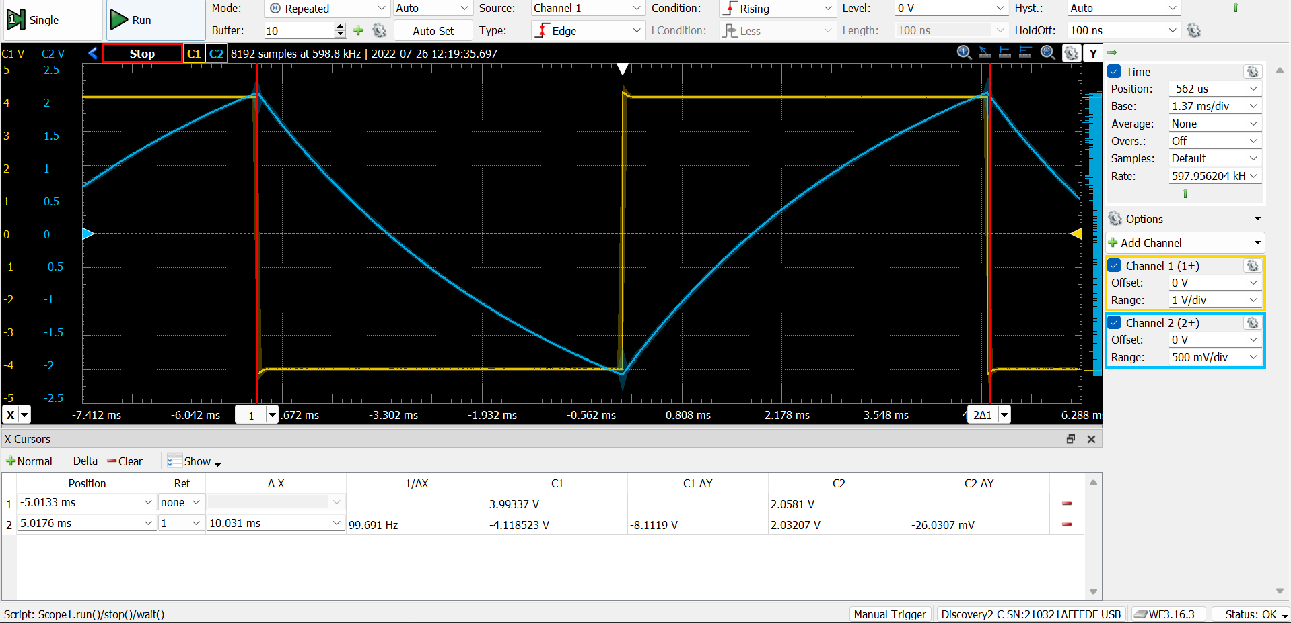

Figure 7: Measured waveforms from lab for Q = 0.25

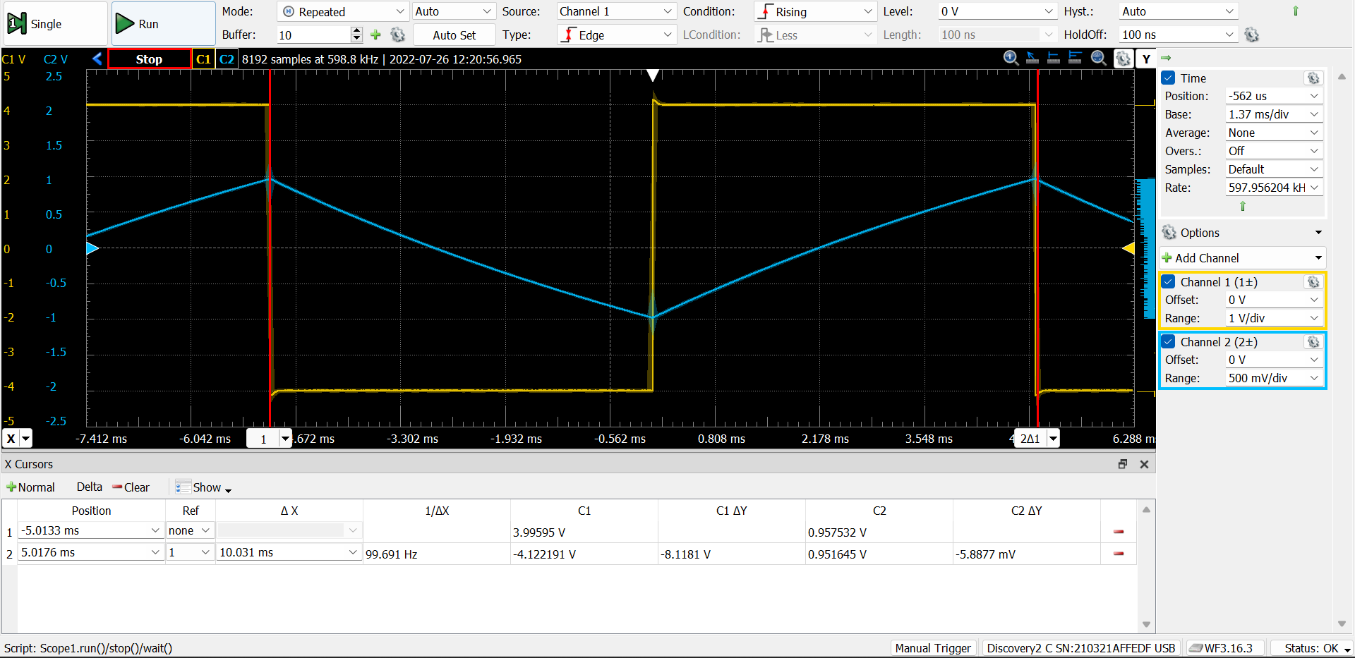

Figure 8: Measured waveforms from lab for Q = 0.1

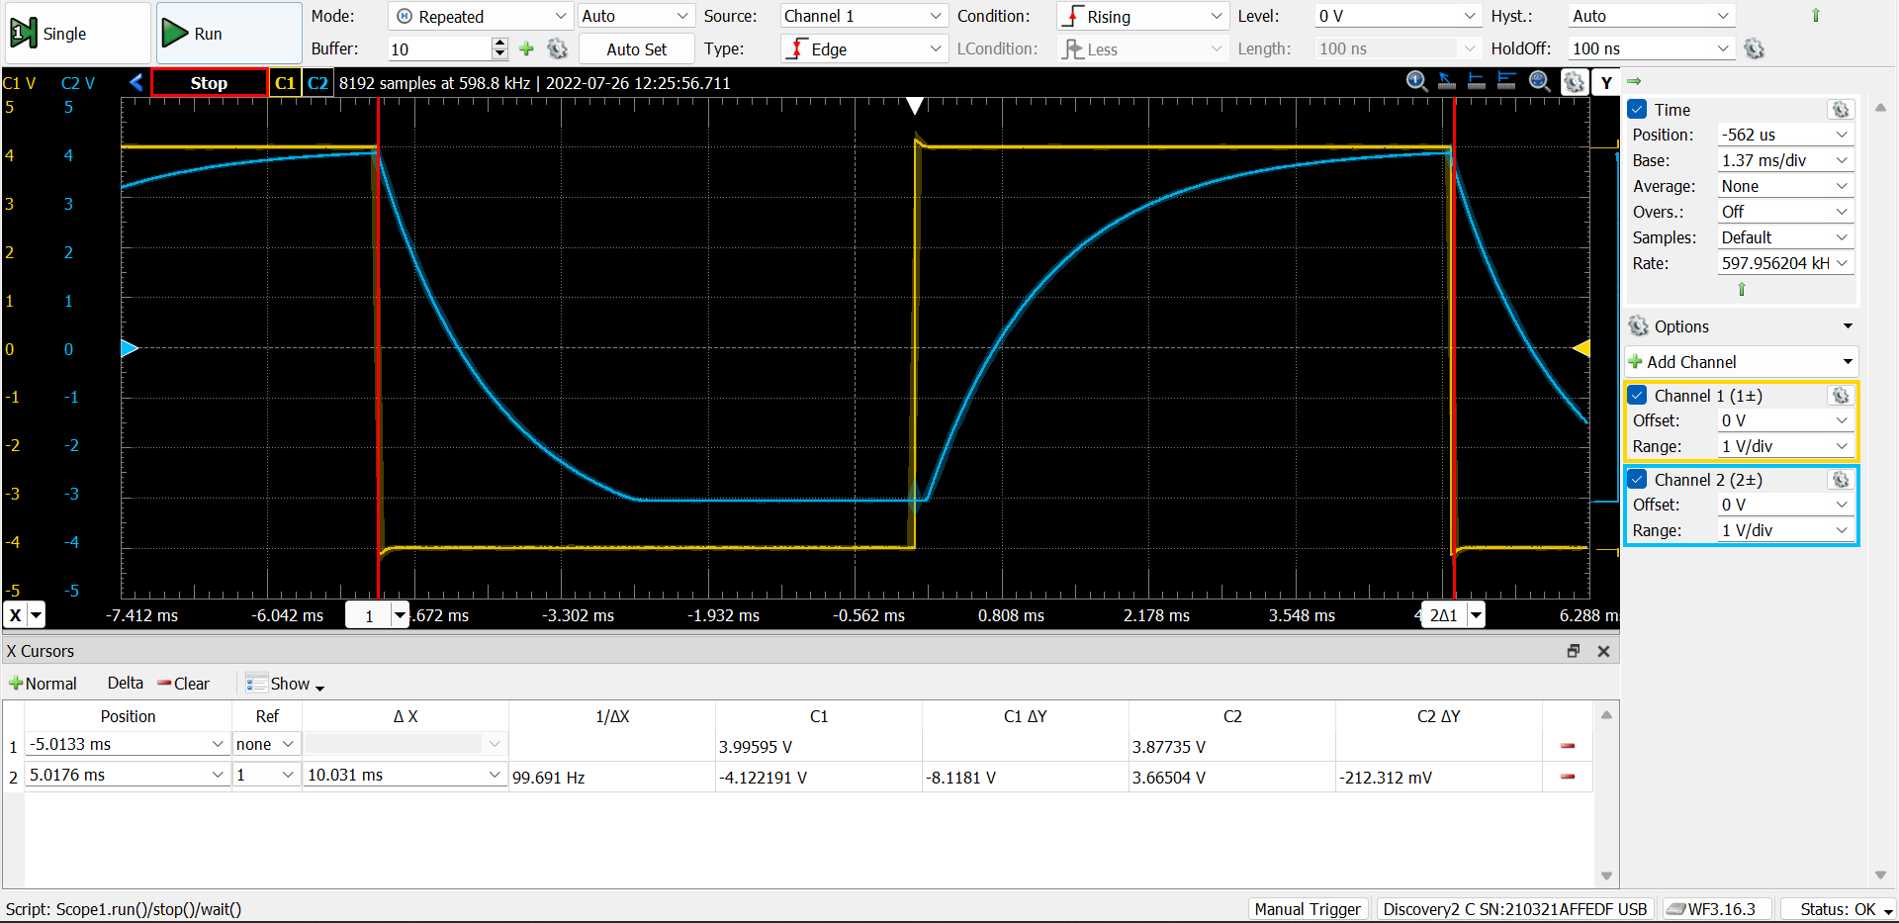

Figure 9: Measured waveforms from lab for Q = 1

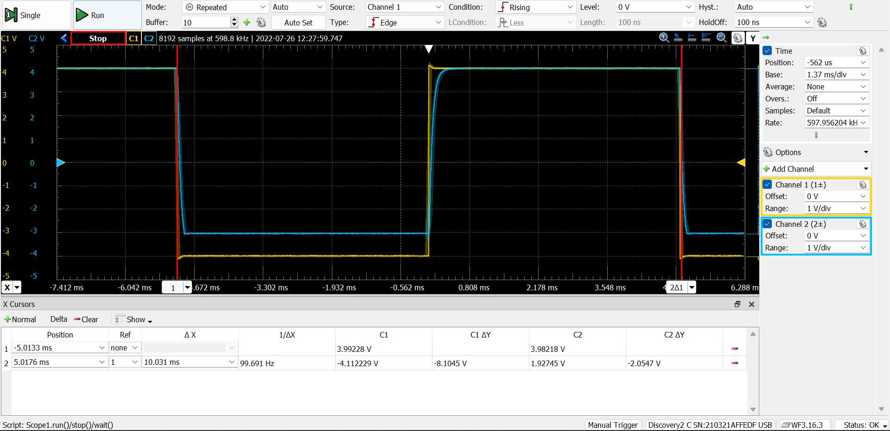

Figure 10: Measured waveforms from lab for Q = 2.5

The most likely cause of these differences is from the actual components having different values than they would be ideally. An actual capacitor may have a lower or larger value than stated. Additionally, assuming ideal behavior of the operational amplifier may add inaccuracies that create additional differences.

1. Discussion

The main change that I could make to the procedure to improve results would be only using components that are close to their described values. Finally, it may improve the results to choose values for the capacitors first since there seem to be more options for resistors than capictors.